Student’s name | …………………………………………………….…… | Grade | 3
Subject | Computer | Quiz No. | 1
Quiz No. ( 1 ) (Answer)

10

write the correct name of each part.

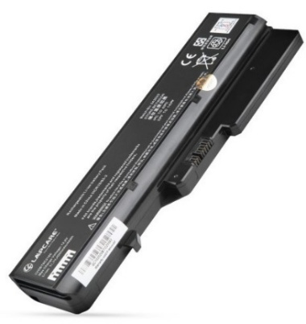
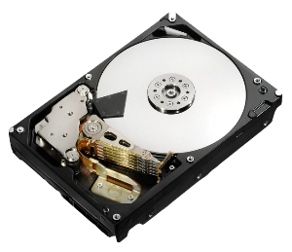
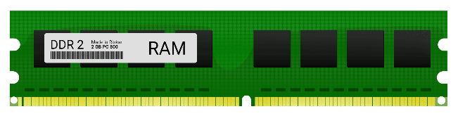
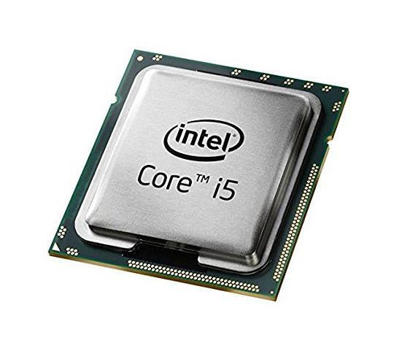
RAM
Battery Laptop
CPU
Hard Disk
Good Luck

Hard Disk
Battery Laptop
RAM
Vector
CPU

